Joint demonstration of ISFP SAFE-STADIUM, H2020 HoloZcan & H2020 NEST projects

On 17 May, it has been a large-scale event at the PGE Narodowy Stadium in Warsaw. The was a Joint demonstration of ISFP SAFE-STADIUM, H2020 HoloZcan & H2020 NEST projects. In the attachment, you will find information about this event as well as the draft of the scenario.
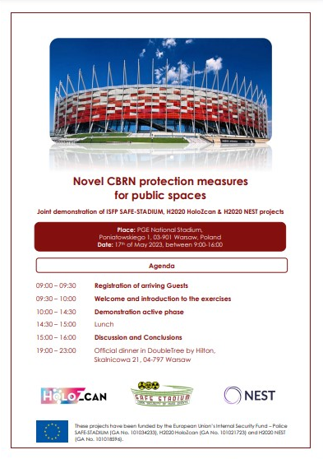

The movie from this event you can find in below link:
https://ksp.policja.gov.pl/dokumenty/zalaczniki/168/168-115321.mp4

Demonstration event at National Stadium in Warsaw

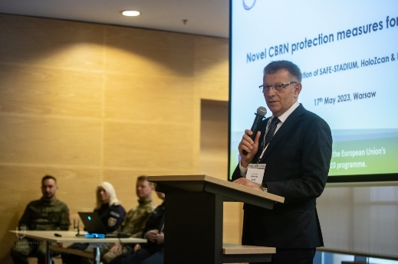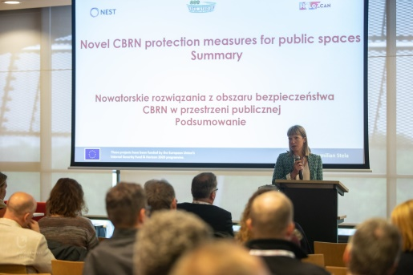
fot. Bartosz Kałużny (CKiPR UŁ)

Three European projects SAFE STADIUM, HoloZcan and NEST joined forces and organized a complex demonstration event at PGE National Stadium in Warsaw on May 17, 2023. The event focused on the latest technological solutions and procedures for protecting public spaces in the context of CBRN terrorist attacks. The event was based on complementary focus of each of three projects. The HoloZcan project is developing a novel AI-supported technology solution for the detection of biological threats, while the NEST project is using multiple sensor systems to detect CBRN agents. The SAFE-STADIUM project focuses on the CBRN protection procedures of sport facilities.

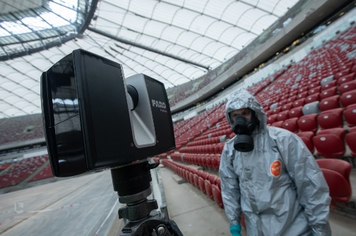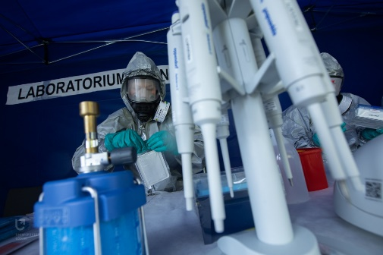
fot. Bartosz Kałużny (CKiPR UŁ)

In accordance with the established scenario, during an improvised football match with the participation of the public, a van was driven onto the pitch, from which terrorists in possession of a dangerous substance ran out. After spraying an unknown chemical agent, the attackers and several other people were killed. The situation required the immediate removal of spectators from the stadium and the implementation of rescue and identification operations and decontamination. In the course of the ongoing operations, it turned out that among the people leaving the facility, there was another terrorist who had released an agent of a biological nature. This complex scenario allowed to test technological solution developed by HoloZcan and NEST project, as well as, procedure developed within Safe Stadium. It also gave an opportunity for police and fire fighter forces to practise cooperation during improvised terrorist attack.

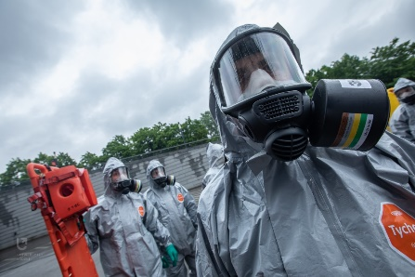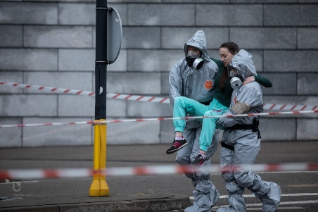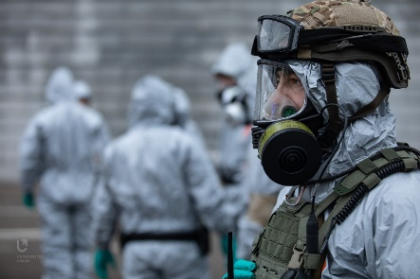
fot. Bartosz Kałużny (CKiPR UŁ)

All three project are financed by European Union: SAFE STADIUM (agreement 101034226 – SAFE STADIUM) by Internal security Funds – police, NEST (agreement 101018596 – NEST) and HoloZcan (agreement 101021723 — HoloZcan) by H2020 programme.

